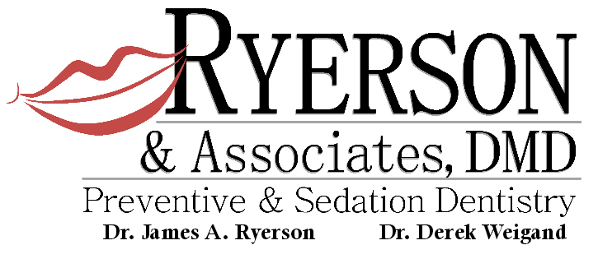

Written Financial Policy

Thank you for choosing Ryerson & Associates, DMD Preventive & Sedation Dentistry. Our primary mission is to deliver the best and most comprehensive dental care available. An important part of the mission is making the cost of optimal care as easy and manageable for our patients as possible by offering payment options. If you have insurance, our office will file your dental charges with all necessary x-rays and information. We will try to estimate your dental benefit toward each procedure, and ask you to pay your portion at the time of service. Each time we contact insurance companies to check your coverage they quote a disclaimer -“BENEFITS QUOTED ARE NOT A GUARANTEE OF PAYMENT”. If we have under-estimated your dental benefit we will bill you, and, if insurance pays more than we estimated, we will be happy to issue a refund. Our payment options are:

- Cash, Check, Debit Cards, Visa, MasterCard, American Express,
Discover, and Flex Plan Cards
- Payment Plans from Care Credit
• 1 year Interest Free available for treatment over $300
• 6 month Interest Free available for treatment under $300
• Convenient, low interest monthly plans also available
• No annual fees or pre-payment penalties

_____ PLEASE INITIAL ACKNOWLEDEMENT OF RECEIPT OF NOTICE OF PRIVACY PRACTICES

_____________________ _____________________ ______
Please Print Name Signature Date

If you have any questions, please do not hesitate to ask. We are here to help you get the dentistry you want and need.
1013 East Avalon Avenue Muscle Shoals, AL 35661
Telephone: 256-381-2100
Fax: 256-381-4844


WARRANTY REGARDING YOUR DENTAL RESTORATION

Restoration: Filling, crown, bridge, partial denture, full denture, root canal or sealant.

While your restoration is made of the best material available, a variety of factors will influence its longevity. We have learned that despite our best efforts, your dental restorations can fail for a variety of reasons that include new decay, fractured tooth, breakage from excessive grinding of one’s teeth, or simply biting down on a hard object such as a fork or bone. In fairness to both the doctor and patient, the following schedule outlines how Dentistry of the Shoals will address fees in the unlikely event that our dental restoration should require replacement within the first five (5) years of service. The five (5) year benchmark is used, as this is the typical period needed to elapse by insurance carriers before they will pay toward a new restoration, based upon current fees:

- First year of service - (from time of placement) 100% coverage
- Second year of service - we pay 70% - you pay 30%
- Third year of service - we pay 60% - you pay 40%
- Fourth year of service - we pay 50% - you pay 50%
- Fifth year of service - we pay 40% - you pay 60%
- Sixth year of service - you pay 100%

As an example, if your restoration requires replacement 18 months after it is delivered, you will be in the second year of service. If a new restoration cost $1,000 at current day fees, you will pay only $300 to have it replaced. Dentistry of the Shoals covers 70% or $700 of the cost of replacement.

Please understand that “year of service” will be determined by the exact date the restoration was delivered to you to the exact date a diagnosis by the doctor or notification by you (by phone or in person) that you believe your restoration has broken.

Thank you,

Ryerson & Associates, DMD

Signature__________________________Witness_________________________Date_________

